PCS

A Lightweight Decentralized Blockchain

Application Development Platform



Whitepaper

beta 1.0

ABSTRACT 3

PART I ：PCS DESIGN CONCEPT AND INNOVATION 4

1.1 The Significance of blockchain birth 4

1.2 Why design PCS 5

1.2.1 Build a Lightweight Blockchain Development System 5

1.2.2 Current Blockchain Technology Weakness 6

1.3 Main Innovations of PCS 7

1.3.1 PCS Humanized Blockchain Programming Operation 7

1.3.2 Intercommunity and Compatibility Design of PCS 8

1.3.3 PCS Enhance the Extensibility of the Bottom Public Layer Chain 9

1.3.4 Support Second Speed Processing 9

1.3.5 Users Use the Network Resources for Free 9

Part II： PCS Implementation Plan 10

2.1 PCS Public Chain 10

2.2 Consensus Mechanism 10

2.3 Technical Advantage 11

2.3.1 Decentralized Mechanism Ensures System Security 11

2.3.2 Weak Audit Mechanism, Free To Issue Passing Certificate 11

2.3.3 Seven-layer model 12

2.4 ACCOUNT 12

2.5 Virtual Machine Independent Architecture Mechanism 13

2.6 Identity and Privacy 13

PART III： PCS APPLICATIONS 14

3.1 Decentralized Application 14

3.2 Use Side Chains to Support Cross-Chain Asset Transactions and Dividends 14

3.3 Support from Multiple Industries 14

3.4 Community Welfare Application 15

PART IV: PCS ASSETS PUBLISHING 15

# ABSTRACT

PCS is a diversified blockchain ecosystem born in the digital currency chain 3.0 era, presents in a form of lightweight blockchain development system, aims to create a comparable to Microsoft world-class development platform, it would subvert Bitcoin, Ethernet and even present stage all blockchain project operation rules and becomes an everyone’s accessible blockchain programming system.

Through the Value Transfer Protocol, PCS system can realize the value of point to point transfer and construct a chain block programming system for individuals according to the agreement, at the same time build a support multiple industries (financial, Internet, supply chain, social contact games, etc.) decentralized application development Platform (DAPP Platform).

Different forms or structures blockchain assets running on the PCS blockchain can be registered, exchanged, stored, and conducted more complex interactions through the blockchain ecosystem. PCS hopes to make it possible for ordinary Internet users to feel the value of blockchain technology by constantly breaking the application boundary and technical boundary of blockchain technology.

Through leading design concepts and innovative design thoughts PCS has been realized. It has technological advantages such as supporting second high-frequency trading, decentralizing mechanism to guarantee system security, weak auditing mechanism, free issuance of pass-through certificate, humanized design, and easy to use. Through introduction of Identity, Oracle and Data feeds, in terms of compliance PCS regulatory requirements are met with different industries. The consensus mechanism of PCS adopts Delegated Proof of Stake mechanism, which avoids resource waste of Proof of Power, makes system faster and safer, and lays foundation for enterprise-level application.

In addition, in aspect of scripts and virtual machines, we will be compatible with EVM in the PCS test network. Later, by marking different virtual machine types, more virtual machines can be supported, including LLVM and Lua, and EVM2.0 and more strictly programming language for VM development.

Finally, Go Mobile is also a key strategy that PCS pays special attention to. In PCS ecosystem, we will work with third-party developers to provide Mobile terminal services from the technical architecture support, including mobile wallet, mobile DAPP application, and smart contract services of mobile terminal. We also encourage third-party developers to join us in developing blockchain mobile terminal services and jointly promote the blockchain technology implementation.

# PART I ：PCS DESIGN CONCEPT AND INNOVATION

## 1.1 The Significance of blockchain birth

In January 3rd, 2009, bitcoin found block was dug out and the first transaction happened in 170th block then, since then opens up a booming era of bitcoin network as a point-to-point value exchange network, although has experienced all kinds crises, until now Bitcoin network has become a valued at about $10 billion point to point network starting from the very beginning.

Blockchain technology brings great change prospects to the digital economy era.

The significance of blockchain lies in that it can build a more reliable Internet system, whose features such as decentralization, traceability, openness and transparency can fundamentally solve the fraud phenomenon in value exchange and transfer. Through further studies, a powerful reduce costs ability of blockchain technology could also be found, including simplifying processes, and reducing some unnecessary transaction and institutional costs.

This capacity has been applied to many social sectors and is more practical to improve current floundering economic environment.

More and more people believe that with the popularization of blockchain technology, digital economy will become more authentic and credible, thus making society economy more impartial and transparent.

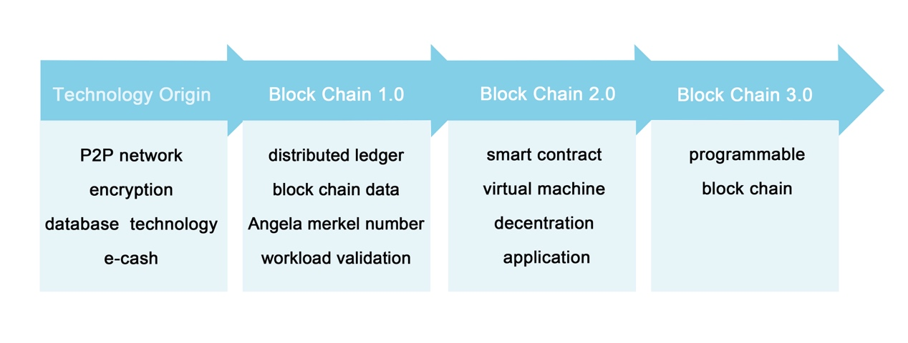

## 1.2 Why design PCS

### 1.2.1 Build a Lightweight Blockchain Development System

Since bitcoin code originated in 2009, blockchain and digital currency have been increasingly accepted by general public. Numerous developers and community members have participated in and witnessed the rapid development of blockchain technology. It has been widely used in various industry innovative practices and has created new ways of service and business operation.

The development of blockchain technology can be divided into three stages: the representative of era 1.0 is bitcoin, the representative of era 2.0 is Ethereum intelligent contract, and one of the most popular blockchain projects EOS has been recognized as the representative of blockchain era 3.0, exploring the development of blockchain application field. EOS is equivalent of IBM, compared with decades of IT leaders IBM and Microsoft. IBM is an international commercial electronics company and has made remarkable achievements in the development of the computer and software industry. But it is still lagging behind Microsoft with a household name. Why?

The definition of Microsoft is completely different from IBM, could be seen from the brand name. IBM is an enterprise-level commercial computer solution, while Microsoft microcomputer is a computer solution directing for individual users. Different positioning results in different achievements of the two companies. Microsoft brings computers and visual operating systems to everyone, greatly improving the efficiency of the whole society, meanwhile Microsoft has become the greatest computer software company.

Today, there is an enterprise-oriented blockchain business solution EOS, as well as an individual-oriented blockchain business solution, which is the "Personal Chain Operation System", personal blockchain operation System PCS.

The so-called personal blockchain operating system does not mean that it is only for individual users. Instead, a lightweight blockchain service should be formed through the blockchain technology, allowing DAPP development to go individual, so that every ordinary user can enjoy the blockchain application.

### 1.2.2 Current Blockchain Technology Weakness

1. **Challenges to the Consensus Mechanism**

A variety of consensus mechanisms have been proposed for blockchain technology common algorithms, the most popular are POW and POS systems. But whether these consensus-building mechanisms can be achieved and guarantee genuine security requires more rigorous verification and time challenge.

The asymmetric encryption algorithm adopted in blockchain may become more and more vulnerable with the development of mathematics, cryptography and computing technology. Now take super computer workforce for example, produce bit coin SHA256 hash algorithm collision takes about 2 ^ 48 years, but with the development of the future quantum computers and other new computing technology, asymmetric encryption algorithm technology in future may have certain break probability. Secondly, under bitcoin mechanism, the private key is stored in user local terminal. If the user's private key is stolen, the user's capital still will be seriously damaged. Whether the private key in blockchain technology is easy to be stolen still needs to be further explored and solved.

**B. Low network throughput**

As we see, under the decentralized design, all nodes are calculating and storing the data of various distributed ledgers, it takes too long time for each calculation to limit transaction volume(1MB). For example, the underlying design of bitcoin only supports 7 transactions per second. Such network throughput cannot support more blockchains commercial application at present

**C. The compatibility between different blockchains is weak**

There exist compatibility problems between different blockchains, such as bitcoin ecology based on the UTXO model and Ethereum ecology based on the Account model. The compatibility of blockchain mainly focuses on three factors of blockchain system, intelligent contract and data layers. It needs to deal with the data of various relational and non-relational types at bottom layer, which will be complicated to implement and requires a lot of compatibility designs.

PCS is designed to solve the problems of low performance, poor security, high development difficulty and excessive dependence on service fee in existing blockchain applications. PCS will create a developer-friendly bottom layer blockchain platform, similar to blockchain operating system, with powerful performance, can support multiple applications running at the same time, can support multiple languages, solved The problems of latency and data throughput through parallel chain and DPOS. The following features are widely introduced: role-based permission management, WEB toolkits for interface development, self-describing connectors, self-describing database systems, and a declarative permission solution to better fulfill PCS's beyond blockchain vision.

## 1.3 Main Innovations of PCS

### 1.3.1 PCS Humanized Blockchain Programming Operation

Microsoft brings a new PC operating experience, a way for everyone to get away from simple, boring strings and use a simpler mouse to operate a PC. PCS will bring a brand new blockchain programming experience, which is somewhat similar to Microsoft's Windows platform by creating a developer-friendly blockchain bottom platform, PCS will support multiple applications running at the same time and provide underlying template for DAPP development. So that all people without the basic programming experience can also write their own blockchain DAPP, so let DAPP development go towards individuals.

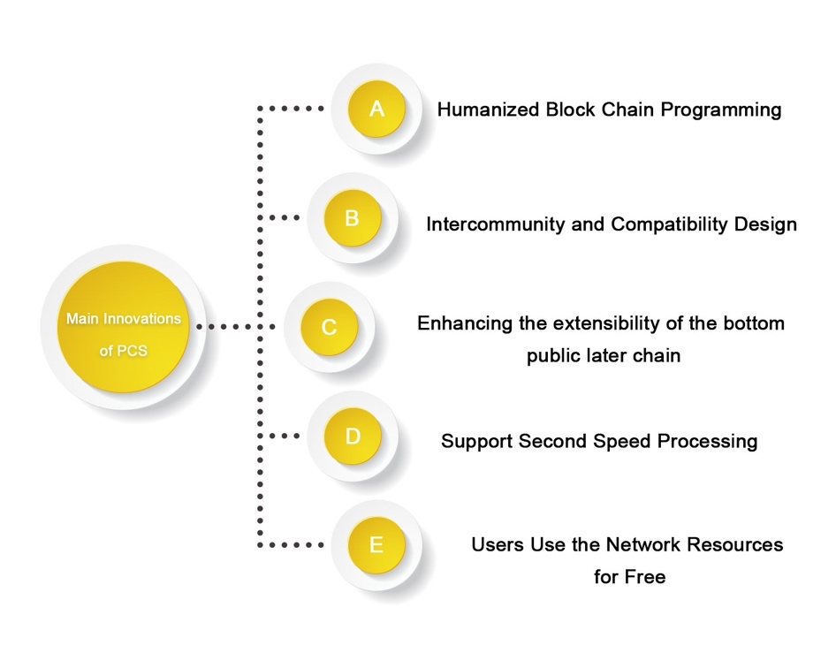

### 1.3.2 Intercommunity and Compatibility Design of PCS

In PCS design philosophy, the consideration of commonality and compatibility is quite sufficient. In the whole digital currency field, we know that based on UTXO model Bitcoin ecology and based on Account model Ethereum ecology are very difficult to have compatibility, along with the development of digital currency, there are nearly 2000 kinds of digital currencies in circulation, and every day there are a large number of new kind, this requests basic public chain has more inclusiveness.

PCS can be designed to be compatible with Bitcoin network and Ethereum network, on one hand providing technical possibilities for using bitcoin BIP protocol in future. And Ethereum will for the first time promote the concept of intelligent contract from theory to practice, so as to expand the boundary of blockchain technology. And so far EVM is the only through intelligent test virtual contract machine, so sustain the EVM compatibility seems really important, and the virtual machine of PCS will keep the compatibility with EVM, all developed on Ethernet network intelligent contracts can also run on PCS platform.

Downward compatibility of software is also a very important issue. The files and smart contracts created with the old version software will be able to run continuously on the new version without forcing user to upgrade, which will bring a lot of convenience to users. Due to the particularity and one-time deployment of the smart contract, if downward compatibility cannot be realized, it will bring great problems to already have been executed smart contracts, and caused software cannot be iterated and upgraded later, as well as EVM2.0 and EVM1.0 cannot be compatible, which is also a problem that blockchain system software designer needs to concern.

### 1.3.3 PCS Enhance the Extensibility of the Bottom Public Layer Chain

As a decentralized operating system, whether consensus can be reached when disagreements arise and iteration can be maintained without hard divarication becomes a crucial matter.

In the running of the public chain, bugs in the bottom layer code are inevitable, but frequent bugs will lose users' trust. PCS public chain solves this problem from the overall architecture design. When the system has error, it can distinguish whether the error is indeed a bug according to the readability intention, and judge whether the community's repair is correct. For example, when the system is under attacked, the nodes in it will quickly take actions to freeze the hacker account, and then take effective measures by voting to avoid the hard divarication problem caused by lack of consensus.

### 1.3.4 Support Second Speed Processing

One of the biggest complaint of Ethernet and most current blockchain apps is that they are "slow" and "congested", especially when transactions are piling up. Currently bitcoin actual application could only support about 7 times transfers per second, and Ethernet only support dozens times of transfers per second. How to achieve high speed processing under the premise of security is the breakthrough point of bottom layer public blockchain.

PCS adopts the DPOS (share authorization certificate) consensus algorithm mechanism, and has achieved tens of thousands of transactions per second under limited test conditions. In the future, PCS will use concurrent technology to continue to expand its network capabilities, with the potential to handle millions of transactions per second. This will settle the rate and scalability issues of the bottom layer public chain and will allow thousands of business-level distributed applications (DAPP) to run on their platforms at the same time.

### 1.3.5 Users Use the Network Resources for Free

Both bitcoin and Ethernetcoin have made good trials in the past, with fees, and PCS users don't have to pay for the platform. This free platform will naturally get more attention. With enough users, developers and enterprises can create corresponding profitable models.

# Part II： PCS Implementation Plan

## 2.1 PCS Public Chain

PCS public chain is a multi-industry application development platform for decentralized blockchain. Based on the development of graphene underlying technology, the advantages of blockchain technology can be brought to users in different industries and ordinary Internet users in a more flexible and convenient way through complete design.

PCS through universality and compatibility of innovation, enhance bottom layer chain expansibility, support second level processing speed and other technical advantages, adopt consensus mechanism of (Delegated Proof of gaining) to avoid resources waste of Proof of Power and Proof of stake, in this way system would be much faster, more secure, laid the foundation for the enterprise level application.

The goal of PCS is to build an open, transparent, safe and diversified ecosystem for enterprise users and ordinary users through continuous research and development and innovation of blockchain technology.

## 2.2 Consensus Mechanism

The consensus mechanism of PCS adopts Delegated Proof of Stake mechanism to avoid resources waste of Proof of Power and Proof of stake, in this way system would be much faster, more secure, laid the foundation for the enterprise level application. According to the DPOS consensus mechanism, the whole network holders of tokens can select the block producers through voting system, and anyone can participate in the block production once be elected.

The PCS are expected to produce a block every 3 seconds. At any time, only one producer is authorized to produce the block. If the block is not successfully blocked in a certain time, the block is skipped.

Block generation in PCS architecture is a cycle of 21 blocks. At the beginning of each block cycle, 21 block producers are selected by voting. Top 20 blockers were selected automatically, and the 21st blocker was selected according to the corresponding probability of the number of receiving votes. The selected producer mixes based on a pseudo-random number exported from block time to ensure that the connection between the blocker is as balanced as possible.

If the blocker misses a block and has not produced any blocks in the last 24 hours, the blocker would be deleted, and this way ensures the smooth operation of the network.

Under normal circumstances, DPOS blockchain does not experience any divarication because block producers collaborate to produce blocks rather than compete. If there is a block divarication, consensus will automatically switch to the longest chain. With more producers blockchain will grow faster than those with fewer producers. In addition, no block producer should produce blocks on two blockchain divarications at the same time. If a block producer has been found done this way, it could be voted out.

## 2.3 Technical Advantage

### 2.3.1 Decentralized Mechanism Ensures System Security

PCS is a "company" with network nodes across all over the world, which means that PCS will not go out of business. PCS can operate automatically at least with 3 computers connected to the Internet. At present, PCS have run dozens of nodes by enthusiasts from several continents around the world. PCS is a fully automated, unattended system like bitcoin, with all its services completed by automatic network operation and intelligent contract.

### 2.3.2 Weak Audit Mechanism, Free To Issue Passing Certificate

Since PCS is a purely decentralized system, weak auditing is adopted. Users are free to use any function of PCS without any restrictions. At the same time, individuals or enterprises are allowed to freely issue their own certificates within the PCS system. All the issued certificates are intelligent contracts and are kept on the PCS account in the blockchain. PCS issuing function is the foundation of blockchain finance. It is committed to combining with traditional Internet and non-internet enterprises and innovating every industry of blockchain national production and life, such as retail industry, catering industry, service industry, cultural and art industry, etc.

### 2.3.3 Seven-layer model

PCS, as a blockchain application and development platform, provides a complete development system and architecture for the entire blockchain technology ecology, improving ecological layout of seven levels, including the resource layer, protocol layer, consensus layer, contract layer, tools layer, decentralized application layer and ecological layer.

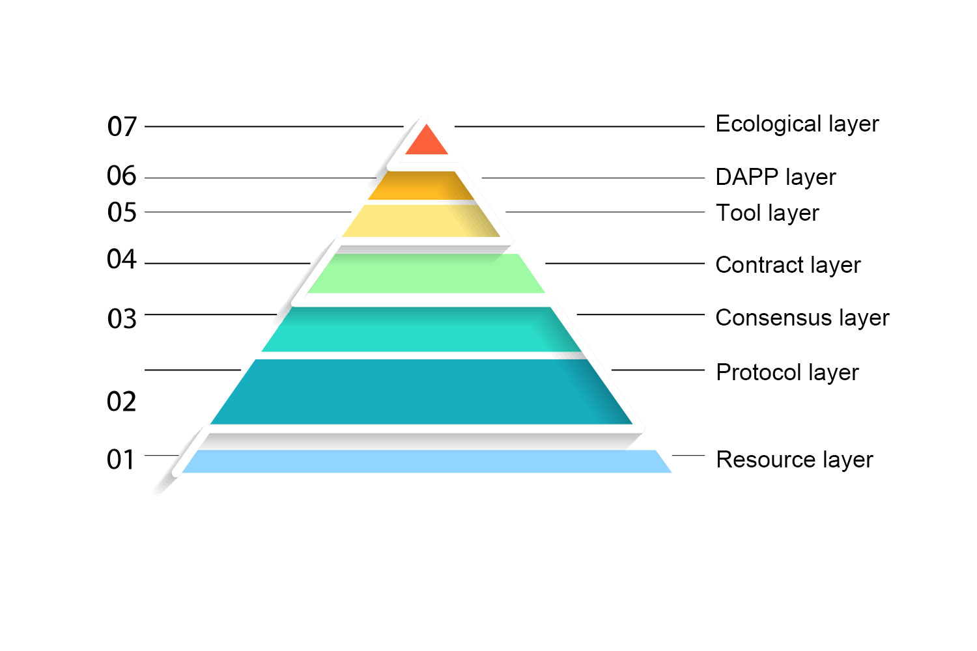

## 2.4 ACCOUNT

PCS allows account references to be implemented using a unique, readable name of 2-32 characters in length, as simple as the existing account system, which has multi-level role management, and provides users with a way to restore their account control when keys are stolen, ensuring account security.

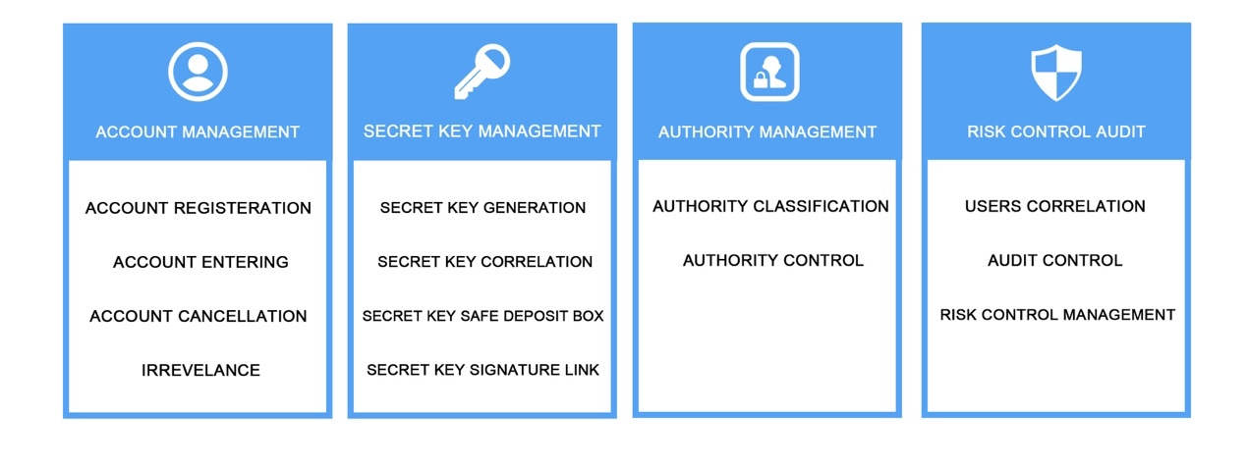

## 2.5 Virtual Machine Independent Architecture Mechanism

At the contract layer, PCS integrates the virtual machine with PCS through open API interface, and the implementation of scripting language and virtual machine will be independent of PCS operating system technology. Any development language or virtual machine with appropriate sandbox of sufficient performance can integrate with PCS through API. PCS is currently designed to support Wren, Web components, and ether virtual machines (EVM), in which circumstance applications on ether net can be transplanted directly to PCS systems with simple modifications. Because of the separation of virtual machine and PCS, developers can choose their skilled programming language for intelligent contracts development, which can make the application development on PCS more flexible, thus greatly reducing the barrier of blockchain technology.

## 2.6 Identity and Privacy

PCS systems will manage users on PCS platforms through intelligent contracts. PCS systems will provide optional identification modules, and Identity is a prerequisite for blockchain systems to connect to the financial system. In PCS system, we distinguish Identity customers from non-identity customers. PCS system developers will develop code based on the appropriate Identity intelligent contract and open the source code to third parties. Through the introduction of third-party credit investigation agencies, customers who pass Identity intelligent contract verification will have more priority in the PCS system.

Regarding privacy, since the PCS system is compatible with the UTXO model, more privacy protection will be provided to the transactions in the PCS system through the encrypted transmission protocol.

# PART III： PCS APPLICATIONS

## 3.1 Decentralized Application

DAPP is running in a distributed network, information of participants is stored securely, privacy is also got good protection, through PCS public chain can realize network node application of decentralized operation, it combines the front-end interface and intelligent contracts, front end users can select various commands, and intelligent contracts support application function and blockchain interaction.

PCS will productize different DAPP ideas, so that ordinary Internet users can truly feel the value brought by blockchain technology. For example, decentralized social network, decentralized storage, decentralized domain name service and decentralized computing service, etc. Through the introduction of incentive mechanism, the concept of sharing economy will be further utilized to change the existing APP market and business model. Under such a model, only commercial model design and user experience can be completed, and the blockchain team can develop blockchain-based applications, which will greatly reduce the access threshold of the blockchain.

With the development of mobile Internet and blockchain technology, developers can carry out the development and landing of more DAPP applications on mobile terminals, so that more users can enjoy the dividend of PCS.

## 3.2 Use Side Chains to Support Cross-Chain Asset Transactions and Dividends

As a decentralized bottom layer public chain, more side chains can be built on PCS, while different side chains constitute the entire PCS ecosystem, in which all assets can be traded and distributed through blockchain technology.

## 3.3 Support from Multiple Industries

In PCS system, the Value Transfer Protocol can be used to realize the value transfer from point to point. Based on this Protocol, a decentralized application development Platform (DAPP Platform) supporting multiple industries (Finance, Internet of Things, Supply Chain, Social games, etc.) can be built to support more complicated business logic.

## 3.4 Community Welfare Application

Users can also choose three community benefit apps, also called intelligent contracts. These intelligent contracts will collect tokens based on the percentage of votes each application receives from Token holders. Elected applications or intelligent contracts can be replaced by newly elected applications or Token holders' intelligent contracts.

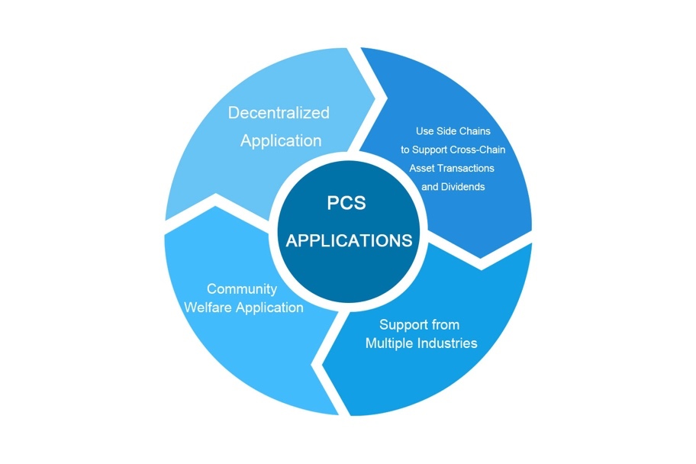

# PART IV: PCS ASSETS PUBLISHING

The Token on the PCS chain is PCS coin, which is a special Token for packaging traders and system participating nodes to distribute. DPOS mechanism is adopted to encourage more miners to participate in its ecology. Publishing PCSX value of PCS coins:

A.Assets Publishing

B.Assets Transaction Fees

C Dividend of Rght to Earnings

D.Asset Exchange On The Chain

